 | Department of Computer Science & Engineering  Independent University, Bangladesh | 

Course Code & Title | : | CSE216L (Microprocessor, Interfacing, and Assembly Language Lab)
Course Instructor | : | Noor-E-Sadman
Assignment No | : | 01
Assignment Title | : | Literature review on the ESP32 S3 Network Honeypot Node
Corresponding CO’s | : | CO1

OBJECTIVES

- Find similar journals according to the assigned topic.
  - Break down your topics into various parts and find related publications (i.e., method, area of research, sensors, topology, algorithm, process, etc.).
  - Review 20-25 recently published Journal Articles. (5 articles per person)
  - Use Google Scholar to find out recent Journal Articles with maximum citations.
  - Write down the summary of each paper. i.e., Methodology, equations, component used, findings, novelty, analysis, the problem faced, future work, etc., and complete the following tasks.

- Keep the following contents in your Literature Review:
  - Statistics
  - Architecture
  - Hardware Components
  - Data Parameters
  - Methodology
  - Result
  - Reference
- Prepare a project budget (component list).

LAB REPORT RUBRICS

Students Name |  | - Abir Hasan Siam  - Mohammad Kabir Hasan  - Shahnaz Raihan Summy  - Md Eleas Biswas |  |  |  |  |  |  |  | Students ID |  | - 2331218  - 2130390  - 2210411  - 2210099
Course Title |  | Microprocessor, Interfacing, and Assembly Language Lab |  |  |  |  |  |  |  | Code |  | CSE216L
Term |  |  | Spring |  |  | Summer |  |  | Autumn | Year |  | 2026
Project Title
Task / Report Title |  | Complete the literature review on the given topics.
Task Justification/ Marking (Tick on the appropriate box)
Rubrics (weight) | Accomplished  (5) |  |  | Intermediate  (4) |  |  | Developing  (3) |  |  |  | Intermediate  (2) |  | Novice  (1)
Find similar journals (10%) | Identified five similar journals with the topics. |  |  | Intermediate between developing & accomplished |  |  | Identified three similar journals with the topics. |  |  |  | Intermediate between novice and developing. |  | Identified one similar journal with the topics.
 |  |  |  |  |  |  |  |  |  |  |  |  | 
Define Summaries with Literature (10%) | Demonstrated sound and precise knowledge of literature in the topic area. |  |  | Intermediate between developing & accomplished |  |  | Demonstrated good and precise knowledge of literature in the topic area. |  |  |  | Intermediate between novice and developing. |  | Demonstrated poor knowledge of literature in the topic area.
 |  |  |  |  |  |  |  |  |  |  |  |  | 
Identify Methodology and Design Requirements (10%) | Identified the methodology properly with the design requirements and specific software used. |  |  | Intermediate between developing & accomplished |  |  | Identified the methodology to some extent with the design requirements and specific software used. |  |  |  | Intermediate between novice and developing. |  | Identified the methodology poorly with the design requirements and specific software used.
 |  |  |  |  |  |  |  |  |  |  |  |  | 
Design Analysis with Equations (10%) | Demonstrated sound analysis of the system with proper equations for seeking a solution. |  |  | Intermediate between developing & accomplished |  |  | Demonstrated good analysis of the system with proper equations for seeking a solution. |  |  |  | Intermediate between novice and developing. |  | Demonstrated poor analysis of the system with approximate equations for seeking a solution.
 |  |  |  |  |  |  |  |  |  |  |  |  | 
Experimentations and Hardware Components (10%) | Exhibited proper experimentation and hardware component requirements to develop the system. |  |  | Intermediate between developing & accomplished |  |  | Exhibited good experimentation and hardware component requirements to develop the system. |  |  |  | Intermediate between novice and developing. |  | Poorly exhibited the experimentation and hardware component requirements to develop the system.
 |  |  |  |  |  |  |  |  |  |  |  |  | 
Investigate the system performance (10%) | Analyzed and interpreted the results properly using the designed parameters. |  |  | Intermediate between developing and accomplished. |  |  | The results are analyzed to some extent according to the defined problem. |  |  |  | Intermediate between novice and developing. |  | The results are poorly analyzed and interpreted.
 |  |  |  |  |  |  |  |  |  |  |  |  | 
Findings and Novelty of the system (10%) | Concluded the results clearly and presented the system novelty. |  |  | Intermediate between developing & accomplished |  |  | Concluded the results to some extent and presented the system novelty. |  |  |  | Intermediate between novice and developing. |  | Concluded the results poorly and presented the system novelty.
 |  |  |  |  |  |  |  |  |  |  |  |  | 
Identify the Problem Faced (10%) | Identified properly the issues that occurred to develop the solution. |  |  | Intermediate between developing & accomplished |  |  | Identified the issues that occurred to develop the solution. |  |  |  | Intermediate between novice and developing. |  | Identified poorly the issues that occurred to develop the solution.
 |  |  |  |  |  |  |  |  |  |  |  |  | 
Indicates the Future Work (10%) | Implied the future work clearly. |  |  | Intermediate between developing & accomplished |  |  | Implied future work. |  |  |  | Intermediate between novice and developing. |  | Implied the future works poorly.
 |  |  |  |  |  |  |  |  |  |  |  |  | 
Identify the Research Gap (10%) | Identified the research gap of all journals properly. |  |  | Intermediate between developing & accomplished |  |  | Identified the research gap of most of the journals properly. |  |  |  | Intermediate between novice and developing. |  | Identified the research gap of some journals properly.
 |  |  |  |  |  |  |  |  |  |  |  |  | 
Sub Total
Literature Review Total (100%)

Faculty Name and Signature:

Abir Hasan Siam-2331218

- Literature Review On Honey-block: Edge assisted ensemble learning model for intrusion detection and prevention using defense mechanism in IoT

1. Statistics
The authors report a significant range of quantitative findings derived from the analysis of 79 state-of-the-art honeypots and honeynets proposed between 2002 and 2020. In the domain of IoT firmware analysis, the FIRMADYNE framework was evaluated using a substantial dataset of over 23,000 firmware images from 42 different vendors. From the 9,486 images successfully extracted, the study identified 887 vulnerable images and discovered 14 previously unknown vulnerabilities. Similarly, the IoTCandyJar honeypot captured 18 million raw requests, of which approximately 1 million were identified as IoT-related, with ports 80, 7547, and 8443 among the most frequently scanned. Statistical analysis of botnet behavior revealed that two Mirai attack patterns accounted for 97.7% of the attacks received during specific honeypot evaluations.
Performance and accuracy metrics vary across the surveyed research. For example, a machine learning-enhanced Cowrie honeypot utilizing a Support Vector Machine (SVM) achieved a classification accuracy of 97.39%. In terms of fileless malware, Dang et al. reported that approximately 9.7% of malware-based attacks on IoT devices are fileless, with 65.7% of these attacks launched through default Linux commands such as rm, kill, and ps. Comparative evaluation of home network defense systems showed an accuracy of 99.84% in detecting specific trojans and ransomware, though this dropped to 48.84% for Torrentlocker. Resource-level statistics indicate that the vast majority of research is virtualized, as components like Programmable Logic Controllers (PLCs) can cost in the order of tens of thousands of dollars.
The taxonomy of IoT honeypots further breaks down application areas: 9 models were for general use, 22 for IoT applications, and 4 for Smart Home environments. In terms of IIoT and CPS, half of the surveyed works utilize low-interaction capabilities. The Conpot framework emerged as a dominant architecture, serving as the foundation for six other developed honeypots. Evaluations conducted over varying durations, such as a 55-day deployment of real Allen-Bradley PLCs and a 7-month evaluation of a smart-factory honeypot, provided long-term data on attack origin dynamics and protocol-specific trends.

2. Architecture
The paper delineates a basic honeynet architecture comprising three essential elements: data control, data capture, and data collection, as depicted in Figure 1. Data control manages traffic flow to prevent attackers from realizing they are in a decoy environment and ensures compromised systems cannot be used to launch external attacks. Data capture is responsible for recording all movements and actions within the honeynet, while data collection involves the secure transfer of this captured data to a centralized location for analysis. The system structure is further defined by front-end components, which interact directly with attackers, and back-end components, which receive data for analysis, decryption, and storage.
The authors provide a comprehensive taxonomy for classifying these architectures based on purpose, role, level of interaction, scalability, resource level, source code availability, and application, as shown in Figure 2. Purpose-driven classifications separate research honeypots, used for information gathering, from production honeypots, which focus on active defense. The level of interaction is categorized into low, medium, high, hybrid, and a newly defined "intelligent" interaction level, which leverages machine learning (ML) to simulate device behaviors without the risk of full compromise. Scalability is another critical architectural factor, with most research favoring scalable designs enabled by virtual resources to mimic large-scale industrial environments.
Specific architectural frameworks are reviewed, such as FIRMADYNE, which uses an instrumented kernel for full system emulation, and HoneyPhy, which utilizes a modular design consisting of Internet interfaces, process models, and device models. The evolution of inheritance among these models is mapped in Figure 4 and Figure 5, showing how older platforms like Honeyd and Conpot have served as the architectural basis for more modern, self-adaptive systems. For instance, self-adapting honeypots are designed to analyze information in real-time and adapt their responses to better accomplish their purpose.

3. Hardware Components
The research surveys a diverse array of hardware components utilized in physical and hybrid honeypot deployments. Common embedded boards and microcontrollers include the Raspberry Pi, which is used for simulating PLCs, acting as a sensor (e.g., Honeeepi), or collecting monitoring information from Ethernet taps. Other platforms mentioned include Beaglebone, Arduino boards for sensor and PLC simulations, and Gumstix boards used for emulating Allen-Bradley PLC functionalities. Network equipment such as the Netgear R6100 and Linksys WRT54GS are also employed as physical honeypots to attract and analyze fileless attacks.
In industrial contexts, real hardware is critical for high-fidelity data capture. The paper references the use of specific industrial devices, including Siemens S7-1200, Allen-Bradley MicroLogix 1100, and Omron CP1L PLCs, which are used to implement realistic roles such as agitators, burner controls, and belt controls. Other specialized equipment includes the SEL-751A relay for building automation and various Remote Terminal Units (RTUs) and Intelligent Electronic Devices (IEDs). Monitoring and industrial hardware also encompass gas-tank-monitoring systems (GasPot), water treatment facilities, and smart grid components such as circuit breakers and transformers.

4. Data Parameters
Data-related parameters discussed in the survey include diverse traffic features, network parameters, and attack indicators. Traffic features often analyzed include start/end times of captures, data bit/byte rates, average packet sizes, and the number of packets per port. Evaluation variables frequently involve the diversity of unique victim IP addresses, attack origins by country, and the correlation of data across multiple honeypots. Packet attributes and protocol data are monitored across a wide range of standards, including Telnet, SSH, HTTP, and specialized industrial protocols like Modbus/TCP, S7comm, EtherNet/IP, DNP3, and IEC 61850.
Attack indicators are categorized by the behaviors they represent, such as brute-force password guessing, reconnaissance scanning, and the execution of malicious shell commands. Monitoring metrics for fileless attacks include CPU usage, process lists, and the symmetry or asymmetry of data flows. In Cyber-Physical Systems, physical process variables are crucial data parameters, including tank water levels, water pump status, and heating/cooling curves for HVAC systems. Furthermore, monitoring equipment like Ethernet taps and loggers (e.g., VNCLogger, Syslog) are used to collect these parameters for detailed behavior analysis.

5. Methodology
The research methodology employed by the authors involves a comprehensive survey and classification of honeypot and honeynet models proposed for IoT, IIoT, and CPS environments. The analytical process began with a systematic review of the literature spanning from 2002 to 2020 to fill a perceived research gap regarding the similarities and differences between existing models. The authors developed a taxonomy creation process by building upon and improving prior survey methodologies, identifying recurring key characteristics that define the current state-of-the-art. This involved classifying each study by purpose, role, interaction level, scalability, resource level, and application.
The classification process was strictly adhered to based on the statements made by the original authors of the surveyed works. For example, the authors categorized systems as honeypots or honeynets based on the original researchers' views, while also identifying inheritance relationships between models. The methodology also included a comparative analysis of the tools used in these studies, such as Shodan, Nmap, and MASSCAN for IoT research, and Wireshark, Snort IDS, and Mininet for IIoT and CPS studies. This systematic approach allowed for the extraction of key design factors for future research.
Data collection within the surveyed works themselves followed specific research procedures, such as deploying Conpot honeypots via Amazon Web Services at multiple global locations or using virtual network simulators like IMUNES and Mininet to scale decoy systems. The authors' analytical process also involved mapping the evolution of these technologies over time to identify how major malware events, such as Stuxnet and Flame, influenced the momentum of research in critical infrastructure security. This holistic methodology concludes by identifying lessons learned and outlining open research problems.

6. Result
The authors found that honeypot and honeynet research has significantly increased in the last decade, but several critical gaps remain. One major finding is the disparity between IoT and CPS honeypots; while IoT decoys primarily support non-specific protocols like Telnet and SSH, CPS decoys focus on industrial protocols and often incorporate realistic simulations of physical processes. A significant advantage of virtualized honeypots was identified, as they enable scalability and cost-effective deployment; however, they may attract fewer attacks than physical hardware. For instance, virtual honeypots attracted 39% fewer attacks and 37% fewer suspicious connections than physical ones in some studies, despite costing 12.5 times less to maintain.
Attack trends identified in the paper show that attackers are increasingly using legitimate search engines like Shodan to find targets, and many attacks on IoT devices are carried out using Mirai botnet patterns. Protocol analysis revealed that Modbus, ICCP, DNP3, and IEC-104 are the most targeted ICS protocols in descending order. The results also highlight that high interaction is essential for identifying complex attacks, yet many CPS honeypots (16 studies) remain low-interaction due to the high cost of industrial hardware and the difficulty of realistic process simulation.
Several challenges and limitations were reported, particularly regarding the detectability of honeypots. Issues such as default hardcoded configurations, missing protocol features, and unrealistic response times can lead to fingerprinting by attackers or search engines. Open issues identified for future work include the need for honeynets in emerging domains like wearables, medical devices, and smart cities, as well as the need for anti-detection mechanisms in virtual decoy systems. The authors conclude that while research honeypots are prevalent, more production honeypots are needed to actively participate in securing networks.

Reference
J. Franco, A. Aris, B. Canberk, and A. S. Uluagac, “A Survey of Honeypots and Honeynets for Internet of Things, Industrial Internet of Things, and Cyber-Physical Systems,” IEEE Communications Surveys & Tutorials, vol. 23, no. 4, pp. 2351–2383, Fourth Quarter 2021, doi: 10.1109/COMST.2021.3106669.

Design and Implementation of ESP32-Based Edge Computing for Object Detection

1. Statistics
The authors report that the experimental evaluation of the proposed system utilizes the ImageNet ILSVRC 2017 dataset, which contains a total of 20,121 images categorized into "person" and "non-person" classes. For the specific task of training the edge-side classification model, the researchers selected a subset of 4,643 images labeled as "person" and 4,500 images labeled as "non-person". During the model development phase, 20% of this training dataset, amounting to 1,829 images, was reserved for validation to assess accuracy and robustness. Performance evaluations were conducted over 900 total iterations, comprising nine distinct combinations of MQTT brokers and operational options, with each combination running for 100 consecutive cycles. The results indicate that the edge-side recognition, utilizing a lightweight MobileNet v1 model, achieved a correctness ratio of 0.76, while the higher-tier YOLOv8 model on the cloud server reached a correctness ratio of 0.98. However, because the system relies on edge-side filtering to reduce transmission, the overall combined accuracy is reported at approximately 0.75, as errors made at the resource-constrained edge dominate the total performance.
The study also provides detailed quantitative findings regarding network latency and power consumption. The authors observed that the distance of the MQTT broker significantly impacts response times: a domestic server (MQTTGO) was 58.5 times slower than a local server, and an international server (Eclipse) was 3.85 times slower than the domestic one. Specifically, Table 1 shows that using a local Mosquitto broker with Option 2 (edge-only recognition) resulted in an average loop time of 860 ± 18 ms, whereas the same option using an international Eclipse broker increased the loop time to 1396 ± 114 ms. In terms of hardware capabilities, the ESP32-CAM features a dual-core 240 MHz processor with 520 KB of internal SRAM and 4 MB of external PSRAM. Power consumption for the device is noted to range from less than 1 mA in deep-sleep mode to over 200 mA during peak activities such as image capture and Wi-Fi transmission.

2. Architecture
The architecture of the proposed system is defined as a hybrid edge–cloud collaboration framework designed to alleviate cloud burdens and reduce latency in real-time object recognition. As illustrated in Figure 4 and Figure 5, the edge-side architecture is built around the ESP32-CAM microcontroller, which serves as both a data collector and an edge server. The software environment on the edge device utilizes TensorFlow Lite for Microcontrollers to run a MobileNet v1 model for initial person recognition. The cloud-side architecture, detailed in Figure 6, employs a laptop running Windows 11 as a cloud server, which uses a Python-based framework integrating OpenCV and the YOLOv8 model for high-fidelity re-verification of detected objects.
Communication within this distributed system is managed through the Message Queuing Telemetry Transport (MQTT) protocol, which utilizes a topic-based publish–subscribe architecture. As shown in Figure 3, the MQTT broker acts as a central hub managing message routing between the edge publisher and the cloud subscriber. The authors evaluate three specific deployment models: Option 1, an extreme setup where all images are transmitted to the cloud; Option 2, where all recognition is performed locally at the edge; and Option 3, a balanced hybrid model where initial recognition occurs at the edge to trigger immediate actions, followed by cloud-based verification for improved accuracy. This design rationale ensures real-time responsiveness by leveraging the edge for speed while maintaining high identification reliability through cloud processing.

3. Hardware Components
The primary hardware platform analyzed in this research is the ESP32-CAM, a low-cost and compact development board that integrates the ESP32 microcontroller with an onboard camera module. The device is powered by a dual-core 240 MHz processor and is equipped with 520 KB of internal SRAM and 4 MB of external PSRAM to accommodate the memory requirements of lightweight deep learning models. The onboard camera module is an OV2640, which supports image resolutions up to 1600 × 1200 pixels, facilitating its use in diverse IoT monitoring applications. To provide local feedback, the authors utilized a 1.8-inch TFT-LCD ST7735S display with a 128 × 160 resolution, which outputs recognition results directly at the source.
For higher-tier processing, a laptop running Windows 11 functions as the cloud server, providing the computational resources necessary to execute the YOLOv8 object detection model. The system also incorporates several peripheral components, including USB-to-UART interfaces for hardware-to-PC communication via the Arduino IDE and LEDs for status indicators. The ESP32-CAM's built-in Wi-Fi module is used to establish internet connectivity for MQTT communication. Monitoring equipment, specifically the Arduino Serial Monitor, is used during the development and testing phases to collect performance logs and analyze system behavior.

4. Data Parameters
The data parameters discussed in the paper include various image formats, network protocols, and evaluation metrics. Captured images can be set to RGB565 or JPEG formats, with supported resolutions including 96 × 96, 160 × 120, 240 × 240, 320 × 240, and 640 × 480 pixels. For processing on the ESP32-CAM, images are converted to RGB888 and resized to a consistent 96 × 96 pixels to match the input layer of the MobileNet v1 model. Communication protocol data is managed via MQTT topics, such as "Topic 1" for raw images, "Topic 2" for text messages, and "Topic 3" for filtered images following edge-side detection.
System performance is monitored through several critical metrics, including average loop time (ms), MQTT transmission time, and classification confidence scores. Confidence scores represent the model's certainty that a "person" is present in the image; for this study, the authors established a threshold of 0.5 for edge-side recognition and 0.80 for cloud-side verification. Data collection and monitoring also involve the use of timestamps (as shown in Figure 21) and the analysis of standard deviation (SD) for timing measurements across different MQTT brokers. Finally, image data is categorized into two labels: "person" for target identification and "non-person" for everything else in the environment.

5. Methodology
The authors conducted the research by following a multi-step methodology that integrates model training, system design, and experimental evaluation. The process began with model selection, where MobileNet v1 was chosen as the edge-side backbone over MobileNet v2 due to its lower computational requirements, making it more suitable for the ESP32-CAM's limited hardware. Training was performed using the Edge Impulse platform, employing a transfer learning approach to adapt a pre-trained network with images sourced from the ImageNet ILSVRC 2017 dataset. As shown in the workflow in Figure 7, this involved creating a project, uploading and manually labeling images, resizing them to 96 × 96 pixels, and adjusting neural network settings such as the number of epochs and learning rate.
The experimental setup involved deploying the trained model onto the ESP32-CAM using the Arduino IDE, where it was exported as a library compatible with TensorFlow Lite for Microcontrollers. To simulate real-world monitoring, the researchers used the ESP32-CAM to capture images of a laptop screen displaying a rotating set of validation images from the ImageNet dataset. This video simulation ran for 10 minutes, encompassing 1200 images changing at 0.5-second intervals. For the cloud-side methodology, four Python programs were executed to manage OpenCV image handling and YOLOv8 re-verification tasks. The analytical process compared three different MQTT brokers—Mosquitto (local), MQTTGO (domestic), and Eclipse Projects (international)—to measure the impact of network distance on system latency. Finally, the authors conducted 200 trials to validate the correctness and confidence scores of both edge and cloud processing layers.

6. Result
The authors found that integrating edge and cloud computing through a hybrid architecture effectively alleviates cloud processing burdens and minimizes bandwidth usage. A key observation is that edge-side pre-processing significantly enhances real-time performance; for instance, the edge server can capture and classify an image in less than 1 second, whereas cloud verification through a domestic broker adds approximately 5 seconds to the total cycle time. The comparative analysis of MQTT brokers revealed that network distance is a critical factor, with international brokers introducing nearly four times the latency of domestic cloud-hosted brokers. This finding importance of performing trivial tasks at the edge to maintain system responsiveness.
Performance outcomes indicate a trade-off between speed and accuracy. While the more complex YOLOv8 model in the cloud achieved a near-perfect correctness ratio of 0.98, the resource-constrained edge device reached only 0.76. Because the system only sends images with a confidence score of 0.5 or higher to the cloud, the combined accuracy was found to be approximately 0.75, as errors made during the initial edge-side classification stage dominate the overall performance. Several limitations were identified, primarily stemming from the ESP32-CAM's restricted 520 KB SRAM and 4 MB PSRAM, which necessitate aggressive image resizing and preclude the use of batch processing. For future applications, the authors suggest exploring multi-node coordination, distributed edge–cloud frameworks, and detailed power consumption analysis to improve scalability in larger IoT networks such as smart cities and smart buildings.

Reference
Y.-H. Chang, F.-C. Wu, and H.-W. Lin, “Design and Implementation of ESP32-Based Edge Computing for Object Detection,” Sensors, vol. 25, no. 6, p. 1656, Mar. 2025, doi: 10.3390/s25061656.
IEEE Citation: Y.-H. Chang, F.-C. Wu, and H.-W. Lin, “Design and Implementation of ESP32-Based Edge Computing for Object Detection,” Sensors, vol. 25, no. 6, Art. no. 1656, Mar. 2025.

IoT-PRIDS: Leveraging Packet Representations for Intrusion Detection in IoT Networks

1. Statistics
The authors report comprehensive statistical findings derived from the analysis of approximately 572 total hours of network traffic, encompassing 99,912,705 packets. This data was condensed into 130,715 unique packet representations to establish a baseline for normal device behavior. Specifically, the profiling phase utilized the CICIoT2022 dataset, which provided 88,810,001 packets over 545 hours, and the CICIoT2023 dataset, which contributed 11,102,704 packets over 28 hours. In terms of comparative performance, the IoT-PRIDS model achieved an overall accuracy of 0.9874, a precision of 0.9384, and a recall of 0.9971, placing it in strong competition with existing machine learning-based approaches as detailed in Table 7.
The significance of these statistics is further reflected in the model's performance across various attack categories. For web-based attacks, the authors achieved a minimum recall of 90% using packet-based detection, which improved to 100% when utilizing flow-based detection mechanisms. Reconnaissance attacks were identified with a minimum of 91% recall and 80% precision across various scan types. Efficiency statistics indicate that the system is capable of near real-time operation; for example, the detection duration (DD) for a command injection attack was only 26 seconds compared to a traffic duration (TD) of 502 seconds. Similar efficiency trends are visible in Figure 7, where the majority of detection times are significantly lower than the actual duration of the network traffic analyzed.

2. Architecture
The architecture of IoT-PRIDS is designed as a host-based, anomaly-based intrusion detection system that leverages "packet representations" to understand typical device behavior. As illustrated in the taxonomy provided in Figure 1, the framework distinguishes itself by its methodology, moving away from heavy machine learning (ML) models toward a lightweight, non-ML approach that relies solely on benign traffic for profiling. The core functional behavior of the system relies on a many-to-one mapping process ($f: \mathcal{P} \rightarrow \mathcal{R}$), which simplifies the complexity and randomness of network packets into a concise set of representations. This process involves three primary stages—deletion, insertion, and conversion—as visualized in the mapping of a UDP packet in Figure 3.
The system design encompasses two distinct operational phases: Profiling and Monitoring, which are overviewed in Figure 4. During the profiling phase, benign network traffic is mapped and archived into a database of device profiles to serve as a benchmark for normal interactions. The monitoring phase subsequently evaluates incoming packets by calculating their Hamming distance from established profiles. The design rationale for this architecture is to minimize computational overhead while maintaining high fidelity in detection. Furthermore, the system can be deployed flexibly as both a host-based and network-based IDS, providing either endpoint-specific monitoring or broader network visibility.

3. Hardware Components
The authors utilized a mid-level Dell laptop as the primary testing platform to evaluate the efficiency and runtime performance of the model. This hardware configuration featured a 13th Gen Intel Core i7-1360P 2.20 GHz processor and 16.0 GB of RAM, running a 64-bit Windows 11 operating system. The system was tested within an environment comprising approximately 80 endpoints, which included single-cast, multicast, and broadcast addresses. This setup demonstrated that the proposed model is sufficiently lightweight for real-world deployment on resource-constrained equipment such as IoT hubs and gateways.
In addition to the testing platform, the paper references specific hardware used within its attack datasets and as examples of vulnerable endpoints. For instance, a Raspberry Pi is mentioned as an attacking device that established communications with a Google Nest Mini smart speaker to facilitate casting activities. The authors also discuss a wide array of hardware categories within the IoT landscape, including medical wearables, remote monitors for healthcare, and smart city sensors used for traffic management. These devices are highlighted as being resource-constrained and often lacking standardized security mechanisms, which necessitates the use of proactive defense solutions like the proposed host-based IDS.

4. Data Parameters
The research leverages two significant datasets: CICIoT2022 for baseline behavior profiling and CICIoT2023 for attack monitoring and evaluation. Data parameters are extracted through a mapping process that considers communication, service, and header fields. Communication parameters include endpoints (IP and MAC addresses), traffic direction, scope (internal LAN vs. external WAN), and distribution (unicast, multicast, or broadcast). Service-related parameters track the underlying protocols (TCP, UDP), port numbers, and specific application services such as HTTP or DNS.
The authors employed rigorous packet header engineering to refine these parameters, removing random or ineffective headers such as ip-total-len, fragment-offset, and various checksums. A synthesized "scope" feature was added to the representations to indicate whether communication was internal or external. To prevent diversity from slowing performance, port numbers were mapped to ranges of 10,000, and payload lengths were converted to the nearest higher power of 2. These engineered parameters allow the system to summarize millions of packets into a manageable number of representations while maintaining the essential characteristics of device behavior.

5. Methodology
The authors conducted the research by developing a novel profiling technique called IoT-PRIDS, which employs a mapping function to summarize large volumes of similar packets into singular representations. The research procedure began by analyzing the simple and repetitive network traffic patterns typical of IoT devices. Based on this observation, the authors established a multi-step methodology for mapping raw packets ($p$) to representations ($r$) through the deletion of random fields, insertion of engineered features like "scope," and conversion of variable values like port ranges.
The classification and evaluation process involved two main phases: a profiling stage where benign traffic from the CICIoT2022 and CICIoT2023 datasets was archived, and a monitoring stage for real-time intrusion detection. The authors defined a distance metric based on the Hamming distance to quantify the degree of abnormality in new packets by finding the minimum distance from the established normal profile. To address the potential for false positives at the packet level, a flow-based detection methodology was introduced, which determines the status of an entire flow based on a voting mechanism (taking the mode) of the individual packet statuses.
The experimental setup included testing the model against five distinct categories of attacks: Web, Reconnaissance, Dictionary Brute Force, DoS, and DDoS. Evaluation metrics included accuracy, precision, recall, and F1-score, which were compared against state-of-the-art machine learning models. The methodology also featured a formal time-complexity analysis to compare IoT-PRIDS with autoencoders, focusing on the profiling and monitoring overhead in real-world scenarios.

6. Result
The authors found that IoT-PRIDS is a highly effective and lightweight solution for IoT intrusion detection, achieving an overall accuracy of 98.74% and a recall of 99.71%. A significant observation from the results is that flow-based intrusion detection significantly outperforms packet-based detection by eliminating false positives and ensuring all malicious flows are identified; for example, the recall for all tested web attacks reached 100% in flow-based mode. Comparative efficiency results, summarized in Figure 7 and Table 8, confirm that the model can operate in near real-time, as detection duration consistently remained below the actual duration of the test traffic.
Theoretical and runtime comparisons with machine learning models like autoencoders revealed that IoT-PRIDS provides a distinct advantage in terms of resource requirements. While ML models require computationally expensive training phases ($O(n^3)$), the profiling phase of the proposed model is $O(1)$ and updateable by simply adding new representations to the database. Furthermore, the system successfully detected attacks even in highly imbalanced datasets, such as DoS and DDoS traffic, where the attack traffic significantly outweighed benign packets.
However, the authors identified certain limitations and challenges, particularly regarding the model's dependence on prior knowledge of specific devices. In dynamic environments where new devices frequently join or leave the network, the model may introduce a higher number of false positives. To address this, the authors suggest future work in integrating human-in-the-loop feedback to enhance detection capabilities over time. Despite these challenges, the study concludes that packet representation is a promising approach for securing the resource-constrained IoT landscape.

Reference
A. Zohourian, S. Dadkhah, H. Molyneaux, E. C. P. Neto, and A. A. Ghorbani, “IoT-PRIDS: Leveraging packet representations for intrusion detection in IoT networks,” Computers & Security, vol. 146, Art. no. 104034, Nov. 2024, doi: 10.1016/j.cose.2024.104034.
IEEE Citation Format: A. Zohourian, S. Dadkhah, H. Molyneaux, E. C. P. Neto, and A. A. Ghorbani, “IoT-PRIDS: Leveraging packet representations for intrusion detection in IoT networks,” Computers & Security, vol. 146, Art. no. 104034, Nov. 2024.

Ensemble Technique of Intrusion Detection for IoT-Edge Platform

1. Statistics
The authors report comprehensive statistical findings derived from the evaluation of the proposed two-stage ensemble technique across four prominent datasets: Bot-IoT, CICIDS2018, NSL-KDD, and IoTID20. In the assessment utilizing the Bot-IoT dataset, the suggested method achieved a remarkably high accuracy of 99.95%, with a balanced accuracy of 99.59% and a precision of 99.14%. Detailed classification results in Table 2 further specify that the system attained a recall of 99.95% for DDoS attacks and 99.36% for benign traffic. In terms of operational efficiency, the average prediction time for the dataset was recorded at 1.23 seconds, outperforming several traditional machine learning methods such as Random Forest, which registered 29.2 seconds, and Extra Tree, which took 65.23 seconds.
In the IoTID20 assessment, the model demonstrated robust performance with an overall accuracy of 99.00% and a balanced accuracy of 99.50%. As documented in Table 5, the technique correctly identified Man-in-the-Middle (MITM) attacks with 99.36% recall and 99.25% precision. The scalability analysis provided in Figure 8 shows that even as the number of IoT nodes increased to 360, the system maintained an accuracy of 92.65%, a sensitivity of 90.12%, and a specificity of 91.32%. Additionally, energy consumption statistics indicate that the proposed model is highly efficient for resource-constrained edge environments, utilizing minimal power of 56.21 mJ for 360 devices, compared to over 60 mJ for competing state-of-the-art techniques.
For the NSL-KDD dataset, which contains over 66,215 total records, the proposed strategy achieved an accuracy of 98.70% and a balanced accuracy of 98.88%. Detailed results in Table 8 show that the system successfully identified R2L attacks with a 93.32% recall rate and U2R attacks with 96.36% recall. Finally, the assessment using an 8% sample of the CICIDS2018 dataset yielded an accuracy of 97.97% and a balanced accuracy of 97.79%, maintaining the fastest classification time on the dataset at 3.23 seconds.

2. Architecture
The architecture of the proposed system is built upon a decentralized edge computing platform designed to process data closer to the physical IoT layer to reduce latency and cloud-transmission burdens. As illustrated in the conceptual overview in Figure 1, the system is organized into three hierarchical layers: the end user layer (comprising edge end devices), the mobile edge networking layer (housing the intrusion detection framework), and the data storage layer (centralized cloud). The mobile edge networking layer specifically incorporates components for distributed traffic monitoring, a data traffic controller, and the proposed hybrid intrusion detection mechanism. Figure 2 provides a broader framework overview, delineating the data flow from distributed sensors through traffic capture and pre-processing modules within the edge computing layer.
The core functional behavior of the system follows a two-stage analytic procedure. The first stage, or detection level, utilizes a binary classifier based on an Extra Tree (E-Tree) to rapidly analyze the flow of IoT data and categorize it as either "intrusive" or "non-intrusive". Safe traffic is allowed to pass automatically via opened gates, while suspicious flows are directed to the second stage for more detailed examination. As shown in the proposed approach in Figure 3 and the ensemble classifier in Figure 4, the second stage (identification level) utilizes a multi-category classifier that integrates E-Tree, Random Forest (RF), and a Deep Neural Network (DNN/MLP) as an ensemble.
The design rationale for this dual-stage architecture is to allow the vast majority of valid network traffic to pass quickly through the lightweight binary stage while subjecting malicious traffic to a more thorough and robust identification process. A combiner module, shown in Figure 4, integrates the probabilistic predictions from the three conceptually diverse models by averaging their outputs and selecting the class with the total maximum probability. This architecture enables the identification of specific attack categories, including DDoS, DoS, Probing, Scanning, and MITM, thereby informing the countermeasure system for appropriate response.

3. Hardware Components
The paper describes a diverse array of hardware components utilized for both the deployment of the proposed system and as part of the monitored IoT infrastructure. For experimental validation, the authors used an Intel i7 processor equipped with 16GB of RAM and a 2.31GHz CPU cycle as the primary platform for system deployment and complex analysis. To realistically simulate the resource-constrained edge environment, a Raspberry Pi v3 with 4GB of RAM and a 1.61GHz CPU cycle was incorporated as the active edge node for performing real-time classification tasks. These hardware selections underscore the model's ability to operate on compact form factors with minimal processing power.
Within the IoT layer, the monitored infrastructure includes heterogeneous devices such as CCTV cameras, which are specifically identified as a source of network activity in the IoTID20 dataset. The study also mentions broader categories of IoT hardware, such as medical sensors, smart home devices, drones, and industrial equipment, noting that these devices often have minimal memory and processing capabilities due to their compact form factors. Additionally, network equipment like routers is identified as a potential location for the installation of multi-category network attack classifiers to enhance security at the communication hub.

4. Data Parameters
The research utilizes a wide variety of data parameters derived from packet analysis and specialized datasets to establish behavior profiles and detect intrusions. The Bot-IoT dataset provides 52 distinct properties to describe the ecosystem of IoT traffic, including attack types like DoS, Recon, and Steal Attacks. For the NSL-KDD dataset, each network connection instance is associated with 42 resources or attributes, 31 of which are observable characteristics gleaned from network connections. To optimize these parameters for edge processing, the authors employed a recursive attribute elimination technique, narrowing the initial collection down to the top 18 most useful characteristics.
Operational parameters include traffic direction, flow patterns, and specific attack indicators such as Botnet Mirai signatures, Man-in-the-Middle patterns, and brute-force attempts. The monitoring metrics used to assess the system's performance include accuracy, precision, recall (sensitivity), F1-measure, and normalized (balanced) accuracy, which accounts for disparities in attack frequency. To address the challenge of imbalanced datasets—where attacks like U2R (User to Root) and R2L (Remote to Local) have significantly fewer instances—the authors utilized the SMOTE (Synthetic Minority Over-sampling Technique) to generate synthetic data instances and produce a symmetrical dataset for training.

5. Methodology
The authors conducted the study using a systematic two-stage procedure for the detection and identification of IoT intrusions at the edge. The methodology begins with a training process, as shown in Figure 5, where raw traffic data is cleaned of invalid records and normalized using a conventional scaling approach. Following normalization, a wrapper approach was used for attribute selection, applying recursive attribute elimination to determine which resources are most critical for the classifier's accuracy. To ensure the models could comprehend patterns of attacks with low incidence, a class balancer stage using SMOTE was implemented to generate additional instances for underrepresented groups in the resource space.
The core classification methodology involves binary detection followed by ensemble-based identification. In the first stage, the E-Tree classifier performs a majority vote across independently trained decision trees to categorize traffic flows. Each decision tree uses a mathematical criterion, specifically the Gini Index, to determine how data should be recursively partitioned into subspaces. If a flow is deemed intrusive, it enters the second stage, where it is reexamined by an ensemble comprising E-Tree, Random Forest, and a Deep Neural Network (MLP). The RF component employs bagging and the CART algorithm to build 11 decision trees that average probabilistic predictions for the final attack class.
Experimental validation was performed using the IOTIFY simulator to assess scalability across a heterogeneous infrastructure of IoT nodes. The methodology also includes a detailed time-complexity analysis to ensure the system can scale to large network environments. The complexity for the best-case scenario—where traffic is immediately classified as benign—is approximated at O(q), where q represents the depth of the trees. By setting maximum depth limitations during training, the authors manage the computational costs and tree structures, ensuring the system remains effective for real-time edge applications.

6. Result
The results of the study indicate that the proposed ensemble strategy is significantly more effective than traditional machine learning methods across all four evaluated datasets. A primary advantage of the two-stage approach is its ability to rapidly release benign traffic while providing detailed information on attack types for malicious events, which benefits both network administrators and defense systems. Specifically, the method achieved balanced accuracy rates of approximately 99.59% for Bot-IoT and 99.50% for IoTID20, consistently outperforming state-of-the-art works and traditional models like DNN, KNN, and NB. The stability analysis in Figure 7 further demonstrates that the presented technique is more durable and robust compared to existing approaches.
Performance outcomes also highlighted the system's efficiency in resource-constrained environments. The proposed method recorded the fastest classification times on the NSL-KDD (1.13 s) and CICIDS2018 (3.23 s) datasets, primarily because the majority of traffic in real-world scenarios is benign and only requires the first level of analysis. Furthermore, the system successfully identified difficult-to-detect attacks, such as MITM and scanning, with hit rates exceeding 98%. Power utilization results, shown in Figure 9, confirmed that the proposed model incorporates a minimal energy requirement of 56.21 mJ even with 360 IoT devices.
Despite these findings, the authors reported several limitations and challenges. The study identified that the system is currently susceptible to certain attack types not addressed in the research, such as wormholes, sinkholes, and forwarding attacks. Additionally, the countermeasures module was only demonstrated theoretically, and the reliance on specific datasets for validation may not fully represent every type of real-world IoT traffic. The results for U2R attacks, while improved to 88% compared to traditional models, remain an area for future optimization. Future research is planned to focus on automated incident response systems, real-time mitigation mechanisms, and privacy-preserving intrusion detection techniques.

Reference
A. Aldaej, I. Ullah, T. A. Ahanger, and M. Atiquzzaman, “Ensemble technique of intrusion detection for IoT-edge platform,” Scientific Reports, vol. 14, Art. no. 11666, May 2024, doi: 10.1038/s41598-024-62319-5.
IEEE Citation Format: A. Aldaej, I. Ullah, T. A. Ahanger, and M. Atiquzzaman, “Ensemble technique of intrusion detection for IoT-edge platform,” Scientific Reports, vol. 14, Art. no. 11666, May 2024. [Online]. Available: https://www.nature.com/scientificreports/

Optimizing IoT intrusion detection system: feature selection versus feature extraction in machine learning

1. Statistics
The authors present a quantitative analysis based on the heterogenous Network TON-IoT dataset, which originates from telemetry, operating systems (Windows and Ubuntu), and network traffic sources. This repository comprises 22,339,021 total instances, although the experimental subset "Train_Test_Network.csv" utilized in this study contains 461,043 total records. Within this evaluation set, 300,000 records are classified as normal traffic, while 161,043 are categorized as attack data. The attack distribution is statistically partitioned into nine specific categories—Backdoor, DDoS, DoS, Injection, Password, Ransomware, Scanning, and XSS—with 20,000 instances each, alongside 1,043 instances representing Man-in-the-Middle (MITM) attacks. The data dimensionality is a key statistical factor, as the original 45 features were reduced to 38 after initial feature elimination and then expanded to 77 parameters following non-numerical encoding.
Numerical performance findings demonstrate clear distinctions between feature reduction methods; for binary classification using a subset of 9 features with a Decision Tree (DT), feature extraction (FE) achieved an accuracy of 86.54% and an F1-score of 85.62%, while feature selection (FS) reached only 80.73% accuracy and 78.44% F1-score. As the number of features increased to 77, the Random Forest (RF) classifier under FS reached 88.22% accuracy and 87.69% F1-score, as shown in Table 10. Runtime statistics indicate that FE is more efficient for reducing small feature sets, such as 9, 22, and 33 features, though the disparity narrows as the feature count increases. Furthermore, for multi-class classification using 9 features, the DT model with FE provided 77.04% accuracy compared to 72.65% for FS. The authors also used T-tests for statistical verification, reporting a significant t-statistic of -9.3139 for accuracy in binary and multi-classification using FE between different feature schemes.

2. Architecture
The architecture of the proposed Network Intrusion Detection System (NIDS) is implemented as a three-phase machine learning pipeline illustrated in Figure 1, consisting of data pre-processing, feature reduction, and classification modules. In the initial pre-processing phase, raw data is cleansed, partitioned, and normalized to ensure a standardized format for analysis. The architecture incorporates two contrasting dimensionality reduction strategies: feature selection (FS), which chooses a subset of the most informative original features to maintain semantic interpretability, and feature extraction (FE), which distills the feature set into a new low-dimensional space via mathematical projection. The design rationale emphasizes building lightweight models specifically tailored to the computational limitations of resource-constrained IoT environments.
The FS architectural module relies on a Pearson correlation score matrix, visualized in Figure 5, to evaluate feature interdependencies and calculate average correlation scores for each attribute according to Algorithm 2. Conversely, the FE module utilizes a Principal Component Analysis (PCA) approach, which involves calculating eigenvectors and eigenvalues of the covariance matrix to project high-dimensional data onto a lower-dimensional representation. Classification is handled by five distinct machine learning models: Decision Tree (DT), Random Forest (RF), k-Nearest Neighbors (kNN), Naive Bayes (NB), and Multi-layer Perceptron (MLP). The data flow moves from normalized training and test sets through these reduction modules into prediction models to categorize traffic as either benign or representing one of the ten multi-class categories defined in Table 1.

3. Hardware Components
The experimental implementation and performance benchmarking were conducted using a specific hardware and software environment detailed in Table 3. The primary computing platform used for constructing and evaluating the NIDS framework was Google Colab, featuring a 2-core Xeon 2.2 GHz processor and 16 GB of RAM. The system utilized 100 GB of disk space and operated on a Linux x86_64 machine. Software components include Python 3.10.12 and libraries such as Scikit-learn, Pandas, Numpy, and Matplotlib.
Beyond the implementation platform, the authors mention various hardware devices that populate the IoT ecosystem, including wireless sensors, smart cameras, televisions, and other smart home devices. These devices are characterized by having very limited security capabilities and being highly vulnerable to cyberattacks, which justifies the development of lightweight IDS models. The authors also note that the data used for testing was generated from telemetry datasets of IoT and Industrial IoT (IIoT) sensors, as well as operating systems from Windows and Ubuntu network traffic.

4. Data Parameters
The TON-IoT dataset parameters are organized into six distinct feature groups: Connection, Statistical, DNS, SSL, HTTP, and Violation. Connection parameters include duration, source and destination bytes, and states such as S0, S1, and REJ. DNS parameters track query subjects, classes, types, and response codes (rcode), while SSL parameters monitor version, cipher suites, and establishment flags. HTTP parameters monitor pipelined depth, request methods like GET and POST, and actual uncompressed content sizes for data transferred from clients and servers.
Evaluation variables and monitoring metrics include Accuracy, Precision, Recall, F1-score, and the Matthews Correlation Coefficient (MCC), which provide a balanced measure of classification performance. The runtime intricacy is also monitored through parameters such as feature reduction time, model training time, and inference time per data sample. Additionally, non-numerical data is processed using encoding schemes, resulting in an increase from 38 initial attributes to 77 parameters, as documented in Figure 2.

5. Methodology
The authors conducted the research using a 3-phase machine learning pipeline that begins with extensive data pre-processing. Raw data from the TON-IoT dataset was cleaned by eliminating non-significant identifiers such as timestamps (ts), source/destination IPs (src_ip, dst_ip), and ports (src_port, dst_port). Missing values were replaced with "n/a" indicators, and 11,071 duplicate instances were removed to ensure data quality. Non-numerical features were converted into numerical ones using label and one-hot encoding based on the characteristics of each feature. Data was then split using a stratified scheme at an 80:20 ratio to maintain nearly the same class distribution in both sets, followed by min-max scaling to normalize values between 0 and 1.
The feature reduction methodology focused on a head-to-head comparison between feature selection (FS) and feature extraction (FE). FS was implemented using Pearson correlation coefficient (PCC) techniques to select features that are not correlated with each other, thereby reducing multicollinearity. Features were chosen based on manually defined average correlation score thresholds, resulting in sets of 9, 22, 33, 47, and 77 features for evaluation. For FE, the PCA technique was applied to both training and test sets to reduce dimensionality while matching the exact number of components selected in the FS iteration for consistent comparison.
The classification process involved five machine learning models: Decision Tree (DT), Random Forest (RF), k-Nearest Neighbors (kNN), Naive Bayes (NB), and Multi-layer Perceptron (MLP). The evaluation approach involved conducting five iterations for each feature number scheme and computing average results for performance metrics and runtimes. Finally, statistical verification was performed using T-tests, calculating t-statistics and p-values to evaluate the significance of the differences between the two reduction methods in both binary and multi-class classification scenarios.
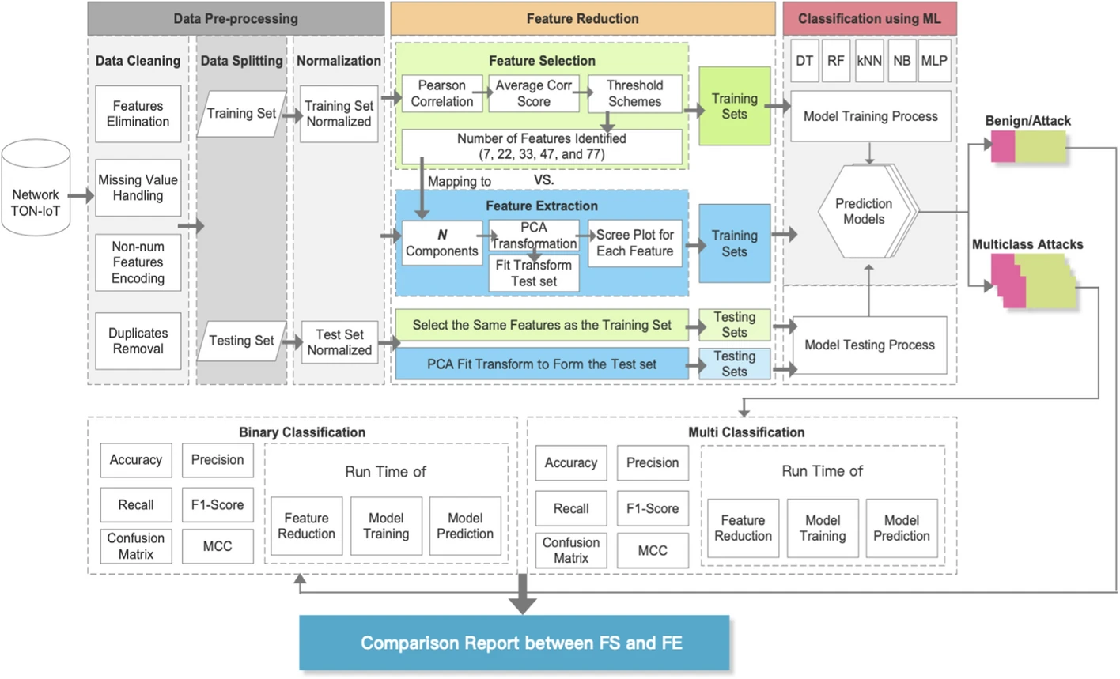

6. Result
The authors found that feature extraction (FE) provides notably better detection performance than feature selection (FS) when the number of reduced features is relatively small, such as 9 or 22 features. For instance, in binary classification using a DT model with 9 features, FE achieved 86.54% accuracy compared to 80.73% for FS. In contrast, as the number of features increases to 33 or more, FS begins to outperform FE. This finding importance is highlighted by the fact that FS has more potential to improve performance as the feature set grows, while FE remains less sensitive to changes in the number of features.
Runtime results indicate that FE is more efficient fordimensionality reduction time compared to FS, especially with smaller feature counts. However, FS generally achieves less model training and inference time than FE, which is a critical advantage for the design of lightweight NIDS in IoT networks. The DT classifier emerged as the optimal choice for runtime efficiency and performance across both reduction methods when feature counts were small, whereas the MLP model performed superiorly as features increased to 33, 47, and 77.
Comparative observations also revealed that FE is capable of detecting a broader range of attack types using the same classifier. Specifically, FE using the best classifiers successfully detected MITM samples, whereas FS failed to accurately identify any MITM instances even with its best models across all feature counts. The authors conclude that detection performance for both methods degrades when the number of features becomes too large due to irrelevant or noisy data, while the F1-score for attack classes is consistently lower than that for normal traffic due to class imbalances in the training set.

Reference
J. Li, M. S. Othman, H. Chen, and L. M. Yusuf, “Optimizing IoT intrusion detection system: feature selection versus feature extraction in machine learning,” Journal of Big Data, vol. 11, no. 36, Feb. 2024, doi: 10.1186/s40537-024-00892-y.
IEEE Citation Format: J. Li, M. S. Othman, H. Chen, and L. M. Yusuf, “Optimizing IoT intrusion detection system: feature selection versus feature extraction in machine learning,” Journal of Big Data, vol. 11, no. 36, 2024. [Online]. Available: https://doi.org/10.1186/s40537-024-00892-y.

Shahnaz Raihan Summy - 2210411

1. Optimizing Internet of Things Honeypots with Machine Learning: A Review
Statistics:
The review sets its motivation against the rapid expansion of the Internet of Things and the parallel rise in attacks that exploit weak default configurations on low cost devices. The authors note that conventional honeypots, although widely deployed, struggle with adaptability and efficiency as attack volumes grow, and that this gap is what machine learning is expected to close. Rather than reporting a single experiment, the paper aggregates evidence from a systematic body of prior work to show that intelligent honeypots consistently improve threat detection and response over static traps, which frames honeypots as a practical first line of defence for constrained IoT nodes such as an ESP32-S3.
Architecture:
The paper organises IoT honeypots along two axes that are directly useful for our project. The first axis is the interaction level, spanning low interaction traps that only emulate a few services, high interaction systems that expose a fuller device surface, and hybrid designs that balance realism against risk. The second axis is intelligence, separating dynamic honeypots that evolve their responses to mislead attackers from adaptive honeypots that react to threats in real time. A recurring architectural pattern is a feedback loop in which captured attacker interactions are fed to a learning component whose output then re-shapes the honeypot behaviour to keep the intruder engaged, as illustrated in Figure 1.
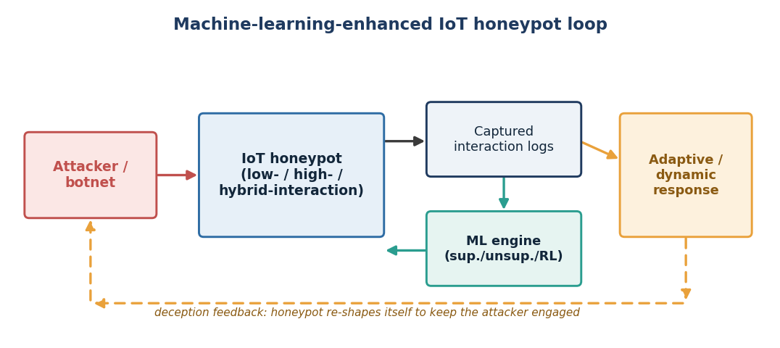
Figure 1. Machine-learning-enhanced IoT honeypot feedback loop (redrawn from the concepts in Lanz et al., 2025).
Hardware Components:
As a review, the paper does not build a single device, but it surveys the deployment substrates that intelligent honeypots run on. These range from emulated software services and virtual machines to physical low cost microcontroller and single board nodes placed on the monitored network. The authors highlight that resource constrained hardware limits how heavy the on-device model can be, which motivates lightweight classifiers and, where necessary, offloading heavier analysis to an edge gateway or cloud back end. This constraint maps closely onto an ESP32-S3 honeypot node, where memory and compute are tight.
Data Parameters:
The data feeding the learning component is drawn from attacker interactions with the trap, including connection attempts, requested services and ports, command sequences, credential guesses and session traces. The review discusses how these raw captures are turned into features suitable for supervised, unsupervised and reinforcement learning, and stresses that feature quality and class balance strongly influence detection performance. It also notes that labelled real world honeypot data remains scarce, which is a limitation for supervised approaches.
Methodology:
The authors follow a systematic literature review using a snowballing method, starting from seed papers and expanding through their citations to build a representative set of studies. Each study is classified by the machine learning family it uses, the honeypot technology it targets and the IoT environment it addresses. The synthesis then compares classifiers such as linear models, decision trees, support vector machines and neural networks, and evaluates how supervised, unsupervised and reinforcement learning each improve detection accuracy or resource efficiency in low, high and hybrid interaction honeypots.
Result:
The review concludes that machine learning materially strengthens IoT honeypots, enabling more resilient and adaptive deception than static traps can offer. Dynamic and adaptive honeypots are found to keep attackers engaged longer and to surface richer intelligence, while the choice of learning technique should be matched to the interaction level and the available hardware. The authors also identify open problems, including limited labelled datasets, the difficulty of evaluating adaptive behaviour fairly and the overhead of running models on constrained devices, all of which are relevant research gaps for an ESP32-S3 honeypot.
Reference:
Lanz, S., Pignol, S. L.-R., Schmitt, P., Wang, H., Papaioannou, M., Choudhary, G., & Dragoni, N. (2025). Optimizing Internet of Things Honeypots with Machine Learning: A Review. Applied Sciences, 15(10), 5251. https://doi.org/10.3390/app15105251

2. An Enhanced LSTM Approach for Detecting IoT-Based DDoS Attacks Using Honeypot Data
Statistics:
The authors frame distributed denial of service attacks as one of the fastest growing perils in the IoT ecosystem, driven by devices that ship with default or weak credentials. They recall the 2016 Mirai outbreak, in which compromised IoT devices generated record breaking traffic volumes, as evidence of how easily unprotected nodes are recruited into botnets. This scale of threat justifies collecting real attacker behaviour through honeypots and training a dedicated deep learning detector on it, which is the exact combination our honeypot node aims to support.
Architecture:
The proposed system is an intrusion detection pipeline built on a hybrid deep neural network. It aggregates a one dimensional convolutional layer to extract local spatial patterns from traffic, a bidirectional long short-term memory block and a bidirectional gated recurrent unit to model temporal dependencies in both directions, and dropout layers for regularisation, before a dense softmax stage classifies traffic as benign or DDoS. Honeypots sit upstream of this architecture as the decoy systems that generate the labelled malicious traffic, as shown in Figure 2.
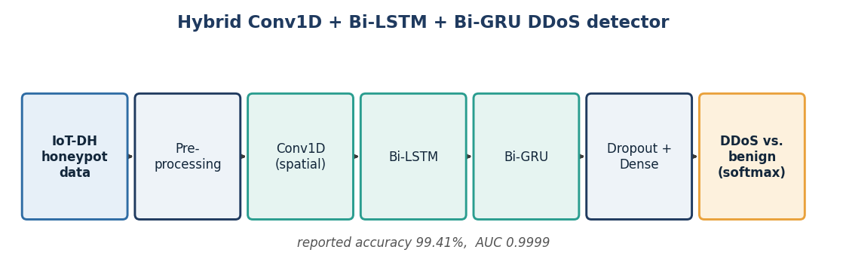
Figure 2. Hybrid Conv1D + Bi-LSTM + Bi-GRU detection pipeline trained on honeypot data (redrawn from Arnob et al., 2025).
Hardware Components:
The contribution is a software model rather than a physical build, so no custom board is presented. The relevant hardware is the honeypot deployment that produced the training data, namely decoy IoT systems instrumented to attract and record attacks. The paper positions the trained model for deployment in dynamic IoT environments and emphasises scalability and real time operation, which implies a capable edge or server host for inference while lightweight sensing nodes feed traffic to it.
Data Parameters:
Training and evaluation use the publicly available IoT-DH dataset, a real world set of honeypot generated IoT traffic labelled for benign and DDoS classes. The model consumes flow and packet level traffic features and learns both their spatial structure, through the convolutional stage, and their temporal ordering, through the recurrent stages. A stated design goal is to minimise false positives so that legitimate IoT traffic is not misclassified, which is a key parameter for a honeypot node that must not raise noise on normal activity.
Methodology:
The authors preprocess the IoT-DH traffic, then train the stacked Conv1D, Bi-LSTM, Bi-GRU and dropout network to jointly capture spatial and temporal features. The model is benchmarked against traditional baseline deep learning models across accuracy, precision, recall and F1-score, and its ability to generalise to both known and unknown DDoS patterns is examined. Careful attention is given to false positive reduction and to keeping the architecture usable in large scale, dynamic IoT settings.
Result:
On the real world IoT-DH dataset the enhanced model reaches an accuracy of 99.41 percent with an AUC score of 0.9999, outperforming the baseline deep learning models used for comparison. The results confirm that combining honeypot sourced data with a hybrid convolutional recurrent detector yields robust, low false positive DDoS detection. The authors point to real time deployment at larger scale as future work, which aligns with running such a detector alongside an ESP32-S3 honeypot feeding it live capture.
Reference:
Arnob, A. K. B., Mridha, M. F., Safran, M., Amiruzzaman, M., & Islam, M. R. (2025). An Enhanced LSTM Approach for Detecting IoT-Based DDoS Attacks Using Honeypot Data. International Journal of Computational Intelligence Systems, 18(1), 19. https://doi.org/10.1007/s44196-025-00741-7

3. IoT-DH Dataset for Classification, Identification, and Detection of DDoS Attacks in IoT
Statistics:
This data descriptor addresses a well known bottleneck in IoT security research, the shortage of realistic, honeypot sourced attack datasets. The authors argue that robust intrusion detection depends on data that reflects genuine attacker behaviour under realistic network conditions, and that many existing sets are simulated or narrow in scope. By capturing multiple DDoS scenarios of varying intensity from a live honeypot, the paper supplies the kind of ground truth an ESP32-S3 honeypot project needs to train and validate its own detection logic.
Architecture:
The data collection architecture centres on a honeypot environment, a system deliberately crafted to attract cyberattacks and reveal the tactics, techniques and procedures of attackers. Traffic directed at the decoy is captured in packet form and then transformed into a structured, labelled table. The overall flow, from decoy exposure through capture to a labelled dataset ready for machine learning, is summarised in Figure 3.
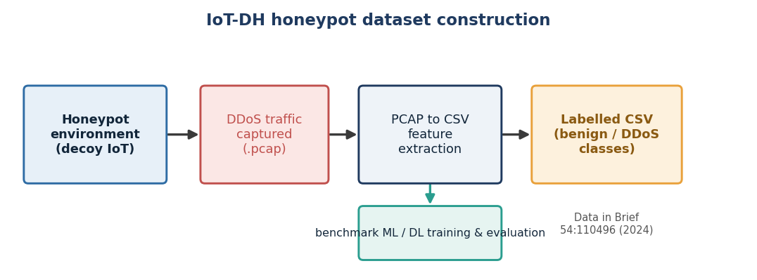
Figure 3. Construction flow of the IoT-DH honeypot dataset (redrawn from Saif, Widyawan & Ferdiana, 2024).
Hardware Components:
The physical substrate is the honeypot deployment that receives and logs hostile traffic, together with the capture host that records network packets. Because the goal is data generation rather than a fielded product, the emphasis is on faithful capture under realistic conditions rather than on a constrained node. For our work the value is the reusable dataset it yields, which can be loaded onto more capable training hardware while the ESP32-S3 remains the sensing decoy.
Data Parameters:
Raw traffic is captured as PCAP and then converted to CSV, exposing traffic features such as timestamps and flow attributes along with class labels distinguishing benign traffic from several DDoS variants. The subject area is documented as anomaly detection, botnet and intrusion detection, and the records are provided as both raw and tabular data. Reported sample evaluation figures, including true positive and true negative counts against a small number of false positives and false negatives, illustrate that the labelling supports high quality supervised learning.
Methodology:
The methodology is a data engineering pipeline. A honeypot is exposed to attract DDoS traffic across multiple scenarios with diverse configurations and intensities, packets are captured, and the PCAP files are converted into labelled CSV feature tables. The authors then validate the dataset by training a classification model and reporting a confusion matrix and classification report, demonstrating that the released data is usable for classification, identification and detection tasks. The dataset is published openly under a Creative Commons licence.
Result:
The paper delivers IoT-DH, a real world honeypot dataset for DDoS classification, identification and detection, together with baseline evaluation evidence that models trained on it perform strongly. Its practical significance is that later studies, including the enhanced LSTM detector reviewed above, adopt IoT-DH as their benchmark. For an ESP32-S3 honeypot node the dataset offers a ready, realistic training and testing resource and helps close the research gap of scarce labelled honeypot data.
Reference:
Saif, S., Widyawan, W., & Ferdiana, R. (2024). IoT-DH dataset for classification, identification, and detection DDoS attack in IoT. Data in Brief, 54, 110496. https://doi.org/10.1016/j.dib.2024.110496

4. Implementation of Lightweight Machine Learning-Based Intrusion Detection System on IoT Devices of Smart Homes
Statistics:
The authors situate their work against a projected growth of connected IoT devices past twenty seven billion, and observe that this boom, driven by cheap sensors and easy connectivity, widens the attack surface for smart homes. They stress that every IoT layer, from sensing to application, is exposed, and that securing microcontroller class devices is hard because of their limited storage and compute. This is the same constraint an ESP32-S3 honeypot faces, which makes the paper an unusually direct reference for our hardware.
Architecture:
The paper proposes a two layered intrusion detection system. The first layer is embedded directly on an ESP32 based smart thermostat and performs binary classification of traffic as normal or attack. The second layer runs on an Amazon Web Services cloud server and performs multiclass classification of a wider range of attacks. The device and cloud communicate over Wi-Fi using HTTP, and a Raspberry Pi 4 acts as an adversary to test the system in real time. The full edge to cloud arrangement is shown in Figure 4.
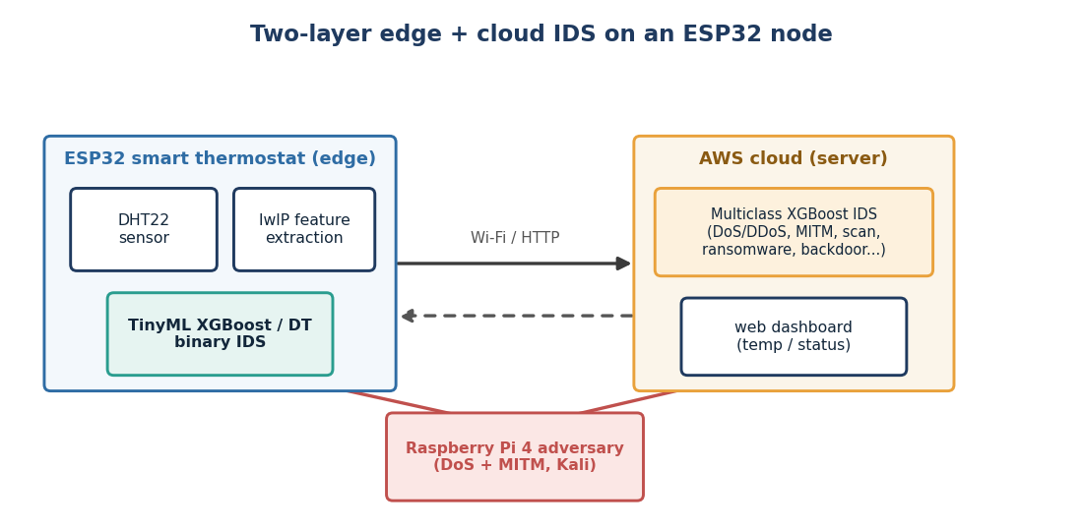
Figure 4. Two-layer edge (ESP32) and cloud IDS with a Raspberry Pi adversary (redrawn from Javed et al., 2024).
Hardware Components:
The edge node is built on an ESP32 microcontroller, reported with roughly 440 KB of ROM and 520 KB of SRAM, paired with a DHT22 temperature and humidity sensor and acting as an HTTP client to the cloud. Because the ESP32 cannot run packet analysers such as Wireshark or tcpdump, the authors extract network features directly through the lightweight IP and socket libraries. The adversary is a Raspberry Pi 4 running Kali Linux, and the second layer runs on an AWS server. This concrete ESP32 build and its memory budget are directly transferable to an ESP32-S3 honeypot.
Data Parameters:
Two data sources are used. The public TON_IoT dataset, with 45 features and a broad set of attack categories, trains the cloud classifier, while a purpose built Intrusion Detection in Smart Homes dataset of 4144 samples covering normal, DoS and MITM traffic supports real time device testing. On the device, only connection activity and statistical activity features that the lwIP library can expose are used, with timestamp and source and destination IP addresses removed to avoid overfitting. Feature selection by chi-square and feature extraction by PCA are also evaluated.
Methodology:
The authors balance the detection load between edge and cloud, then train several models, including XGBoost, decision tree, random forest, artificial neural network, LSTM, Conv1D and MLP. Device side models are embedded with the TinyML library for binary classification, and the cloud model handles multiclass detection. Real time validation is performed by launching ARP spoofing based MITM attacks and hping3 based DoS floods from the Raspberry Pi adversary against the thermostat, and the models are compared on accuracy, inference time, memory footprint and false positive and false negative rates.
Result:
On the cloud, XGBoost achieved the best multiclass detection accuracy of 99.50 percent, with random forest close behind. On the device, the decision tree gave the fastest inference at about 11 microseconds with 99.85 percent accuracy on the training dataset, while XGBoost was preferred overall for its superior accuracy and low error rates. Against live attacks generated by the adversary, the embedded XGBoost IDS detected DoS and MITM at about 97.59 percent accuracy in a few milliseconds. The study confirms that a useful IDS can run inside an ESP32 class device, and its main limitation, the restricted set of network features reachable through lwIP, is a concrete research gap for our honeypot to address.
Reference:
Javed, A., Ehtsham, A., Jawad, M., Awais, M. N., Qureshi, A.-u.-H., & Larijani, H. (2024). Implementation of Lightweight Machine Learning-Based Intrusion Detection System on IoT Devices of Smart Homes. Future Internet, 16(6), 200. https://doi.org/10.3390/fi16060200

5. An Optimized Approach to Deep Learning for Botnet Detection and Classification for Cybersecurity in IoT Environment
Statistics:
The paper opens on the surge of IoT based DDoS activity that has accompanied IoT growth, and argues that botnets remain one of the most damaging threats because they quietly recruit weak devices into command and control networks. It notes that botnets increasingly use encryption and evasion to bypass traditional signature based defences, which motivates learning based detection. For a honeypot node whose captured traffic will often be botnet reconnaissance and recruitment, an accurate botnet classifier is a natural downstream component.
Architecture:
The proposed technique is a gorilla troops optimizer with deep learning enabled botnet attack detection and classification, abbreviated GTODL-BADC. Its structure is a staged pipeline: traffic is normalised and cleaned, informative features are selected, a deep learning classifier assigns a botnet or benign label, and a nature inspired gorilla troops optimizer tunes the classifier hyperparameters to maximise detection quality. The pipeline and its optimisation feedback are shown in Figure 5.
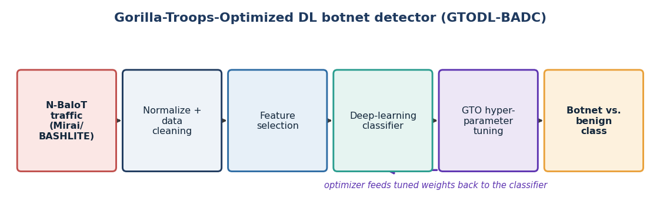
Figure 5. Gorilla-Troops-Optimized deep learning botnet detector, GTODL-BADC (redrawn from Alzahrani, 2024).
Hardware Components:
The work is algorithmic and evaluated on a benchmark dataset, so it does not present a hardware build. Its intended operating context is IoT security infrastructure, where anomaly and botnet detection models watch device behaviour and network traffic. In a deployed setting the classifier would run on a gateway or server, taking traffic summaries from lightweight nodes such as an ESP32-S3 honeypot rather than executing on the microcontroller itself.
Data Parameters:
Detection relies on behavioural and network traffic features that reveal botnet activity, such as sudden traffic increases, unusual command and control patterns and irregular device behaviour. The approach is evaluated on the widely used N-BaIoT data, which was gathered by infecting nine IoT devices with the Mirai and BASHLITE families, giving realistic malicious and benign traffic. Preprocessing and feature selection reduce the feature space before classification to improve efficiency and accuracy.
Methodology:
The method first preprocesses and normalises the traffic, then applies feature selection to retain the most discriminative attributes. A deep learning model performs the botnet classification, and the gorilla troops optimizer, a metaheuristic inspired by gorilla group behaviour, searches for hyperparameter settings that improve detection performance. The tuned model is then evaluated for its ability to separate botnet traffic from benign activity across the attack families in the dataset.
Result:
The optimised GTODL-BADC approach reports strong botnet detection and classification performance, with the metaheuristic tuning improving results over an untuned deep learning baseline. The authors note scalability to very large IoT deployments and validation across more diverse environments as open issues, and recommend adding further security layers and improving real time response. These gaps, especially real time operation on constrained deployments, are directly relevant to pairing such a classifier with an ESP32-S3 honeypot.
Reference:
Alzahrani, A. (2024). An Optimized Approach to Deep Learning for Botnet Detection and Classification for Cybersecurity in Internet of Things Environment. Computers, Materials & Continua, 80(2), 2331-2349. https://doi.org/10.32604/cmc.2024.052804

Mohammad Kabir Hasan - 2130390

1. Securing Smart Cities Through Machine Learning: A Honeypot-Driven Approach to Attack Detection in IoT Ecosystems
Statistics:
The paper opens on the rapid adoption of IoT devices in smart cities and the parallel surge of cyberattacks that exploit their expanded entry points. The authors stress that interconnected sensors create many vulnerable targets, that a single breach can leak personal data and disrupt whole urban services, and that traditional security measures cannot keep pace with the sophistication of modern attacks. This framing motivates using honeypots to gather real attacker behaviour and feeding that data to machine learning, which is exactly the honeypot plus detection pairing our ESP32-S3 node aims to serve.
Architecture:
The proposed architecture is a honeypot-driven detection pipeline rather than a single device. Honeypots that simulate vulnerable IoT devices collect real world attack traffic, that traffic is turned into labelled datasets, and a chain of preprocessing, feature selection and classification then flags malicious activity. The authors structure the study around three objectives, namely identifying suitable IoT honeypot datasets, evaluating machine learning algorithms for threat detection, and proposing comprehensive security solutions, and the overall flow is summarised in Figure 1.
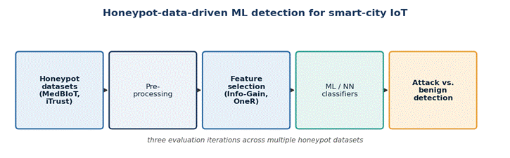
Figure 1. Honeypot-data-driven machine learning detection pipeline for smart-city IoT (redrawn from Ahmed et al., 2024).
Hardware Components:
Because the work is data and algorithm centric, it does not build a physical board. The relevant hardware is the honeypot infrastructure that simulates IoT devices and captures attacks, together with the computing platform on which the models are trained and evaluated. For a physical ESP32-S3 honeypot this paper is useful less for its hardware and more for its demonstration that honeypot sourced data, once captured, materially improves downstream detection.
Data Parameters:
The study draws on real world honeypot and IoT attack datasets, including the MedBIoT dataset of medical IoT botnet traffic and data from the iTrust research centre, which supply both benign and malicious samples. Feature selection is central to the method, with Information Gain and OneR used to rank and reduce features before classification. The authors also examine how feature selection choices affect detection quality across repeated evaluation runs, underlining that feature quality, not just model choice, drives performance.
Methodology:
The authors assemble attack datasets from honeypots that simulate IoT devices, preprocess them, and apply feature selection using Information Gain and OneR. They then train and compare several machine learning and neural network algorithms, including probabilistic and rule based classifiers, and repeat the evaluation across three iterations to test stability. Detection performance is compared against a baseline to quantify the benefit of integrating honeypot data into the security framework.
Result:
The experiments show a clear and consistent improvement in attack detection and mitigation when honeypot data is folded into the IoT security framework, confirming the value of the honeypot-driven approach. The authors report that appropriate feature selection strengthens classifier performance and that the combined pipeline offers practical, deployable protection for smart city IoT. They frame the persistent shortage of realistic, IoT-specific honeypot datasets as an open research gap, which is directly relevant to any node that both traps attackers and generates such data.
Reference:
Ahmed, Y., Beyioku, K., & Yousefi, M. (2024). Securing smart cities through machine learning: A honeypot-driven approach to attack detection in Internet of Things ecosystems. IET Smart Cities, 6(3), 180-198. https://doi.org/10.1049/smc2.12084

2. HoneyIoT: Adaptive High-Interaction Honeypot for IoT Devices Through Reinforcement Learning
Statistics:
The authors argue that deploying honeypots is one of the most effective ways to study IoT attacks, but that building convincing high-interaction honeypots is hard because IoT devices are so heterogeneous and their vulnerabilities depend on specific device types and firmware. They note that attackers now run pre-attack checks to fingerprint a device before committing, and that conventional honeypots are easily unmasked because their replies differ from the real devices they imitate. Their live deployment gives concrete scale, with one honeypot instance recording tens of thousands of attack sessions over two months, which shows how much data a credible trap can harvest.
Architecture:
HoneyIoT is an adaptive high-interaction honeypot built around a reinforcement learning core. A real device based collection system first learns how attackers interact with genuine IoT devices, the attacker and honeypot exchange is modelled as a Markov decision process, and a reinforcement learning agent learns which response best keeps the attacker engaged at each step. A differential analysis stage then mutates selected fields of the reply, such as date values, to produce high-fidelity, device-like responses. The full loop is shown in Figure 2.
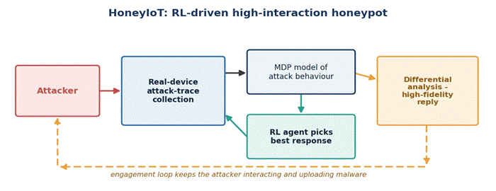
Figure 2. HoneyIoT reinforcement-learning engagement loop (redrawn from Guan et al., 2023).
Hardware Components:
HoneyIoT is trained from traces of real IoT devices, including several camera, router and smart plug models, so genuine hardware sits behind its response model even though the deployed honeypot itself runs as a networked service. For evaluation the trained honeypots were hosted on Amazon Web Services and exposed on the public Internet. This design shows how an inexpensive node such as an ESP32-S3 could present a high-fidelity device persona while heavier learning runs on a back end.
Data Parameters:
The learning signal comes from captured attack traces, that is the sequences of attacker requests and the corresponding device responses, encoded into the states, actions and rewards of the Markov decision process. Key measured parameters include the number of attack sessions, the count of vulnerability exploitation attempts, the volume of malware collected and the average session length, all of which quantify how well the honeypot sustains attacker engagement. Response fidelity is maintained by mutating specific reply fields rather than returning static answers.
Methodology:
The authors collect real device attack traces, model the interaction as a Markov decision process, and train a reinforcement learning agent to select engaging responses, using differential analysis to keep the mutated replies realistic. They then deploy HoneyIoT alongside a non-learning baseline and the open-source Snare and Tanner honeypot on the public Internet for about two months, and compare all three on engagement and stealth. They also test covertness against widely used reconnaissance and honeypot detection tools.
Result:
HoneyIoT effectively bypasses attacker pre-attack checks and lures intruders into uploading malware, outperforming the baseline and the open-source honeypot on engagement. In the two month deployment a single router persona recorded tens of thousands of attack sessions and collected hundreds of malware samples, and the smart plug persona showed similar reach at smaller scale. The honeypot also remained covert against common detection tools. The reliance on a back end for reinforcement learning and on prior device traces is a limitation, and it points to the research gap of running high-fidelity deception on constrained nodes like the ESP32-S3.
Reference:
Guan, C., Liu, H., Cao, G., Zhu, S., & La Porta, T. (2023). HoneyIoT: Adaptive High-Interaction Honeypot for IoT Devices Through Reinforcement Learning. In Proceedings of the 16th ACM Conference on Security and Privacy in Wireless and Mobile Networks (WiSec '23), 49-59. https://doi.org/10.1145/3558482.3590195

3. AIIPot: Adaptive Intelligent-Interaction Honeypot for IoT Devices
Statistics:
The authors highlight that the sheer number and heterogeneity of IoT devices, produced by many manufacturers and using many protocols, makes them prone to vulnerabilities such as weak or hard coded passwords, and that this same diversity makes hand crafting low and high interaction honeypots for every device unaffordable. They position deception, and honeypots in particular, as a prominent and cost efficient way to identify vulnerabilities before attackers exploit them, which motivates automating honeypot responses with machine learning.
Architecture:
AIIPot is an intelligent-interaction honeypot whose responses are generated automatically rather than scripted by hand. Incoming attacker requests reach a honeypot front end, a request and response database stores observed interactions, and a machine learning response generator, drawing on reinforcement learning and language modelling ideas similar to chatbots, produces adaptive replies. The design goal, illustrated in Figure 3, is to extend the length of attacker sessions and thereby capture more attack behaviour.
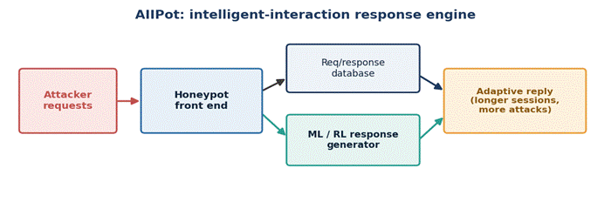
Figure 3. AIIPot intelligent-interaction response engine (redrawn from Mfogo et al., 2023).
Hardware Components:
The contribution is a software honeypot with a learned response engine, so the paper does not present a dedicated hardware build. Its operating context is the IoT network it is meant to protect, where the honeypot is exposed to attract attackers while the learning and the request response database run on a supporting host. The approach is relevant to an ESP32-S3 honeypot as a model for how automatically generated responses can replace laborious manual emulation.
Data Parameters:
The system learns from the stream of attacker requests and the honeypot responses it stores, and it tracks the volume of information received per session as a measure of engagement. Session length is the central quantity the model tries to maximise, on the reasoning that longer interactions reveal more of the attacker's tactics. These interaction records form both the training material for the response generator and the evidence used to evaluate it.
Methodology:
The authors build a honeypot that uses machine learning, including reinforcement learning and natural language style response generation, to interact with attackers automatically. Observed request and response pairs are collected into a database and used to train and refine the response engine, so that the honeypot adapts its replies to sustain engagement. The resulting system is evaluated by how far it extends session length and how many attacks it captures compared with conventional honeypots.
Result:
The evaluation indicates that AIIPot lengthens attacker sessions and captures more attacks on the IoT network than static honeypots, demonstrating that an automatically learned response engine can make deception both scalable and more convincing. By removing the need to hand craft interactions for every device type, the approach addresses the affordability problem the authors raise. Its dependence on a learning back end and accumulated interaction data is a practical constraint and a research gap for deployment on constrained IoT hardware.
Reference:
Mfogo, V. S., Zemkoho, A., Njilla, L., Nkenlifack, M., & Kamhoua, C. (2023). AIIPot: Adaptive Intelligent-Interaction Honeypot for IoT Devices. In IEEE International Symposium (arXiv:2303.12367). https://arxiv.org/abs/2303.12367

4. The Sweet Taste of IoT Deception: An Adaptive Honeypot Framework for Design and Evaluation
Statistics:
The authors frame the rapid proliferation of IoT devices as a source of unprecedented security challenges for critical infrastructure, and present honeypots and honeynets as promising deception technologies for detecting, deflecting and investigating IoT-specific threats. They observe that traditional security measures struggle to keep pace with the growing sophistication and scale of attacks, which is why they argue for adaptive honeypots that change their behaviour in response to what attackers actually do.
Architecture:
The paper proposes an integrated framework with two tightly linked components. The first is an adaptive honeypot architecture that dynamically adjusts its behaviour based on observed attack patterns and integrates with intrusion detection systems. The second is an evaluation methodology that supplies quantitative metrics for judging how effective an IoT honeypot is. The relationship between the adaptive honeypot, the intrusion detection system and the evaluation component is shown in Figure 4.
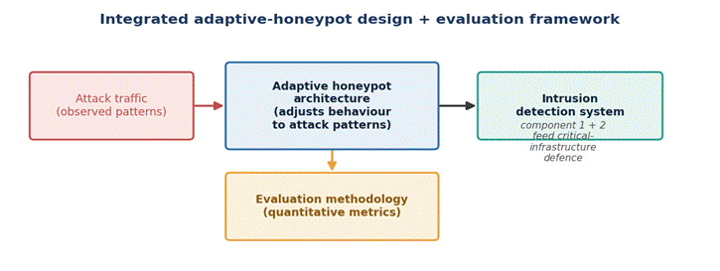
Figure 4. Integrated adaptive-honeypot design and evaluation framework (redrawn from Morozov et al., 2024).
Hardware Components:
This is a framework and methodology paper rather than a device build, so no specific board is presented. The intended deployment context is critical infrastructure protection, where adaptive honeypots sit within a wider IoT network and feed an intrusion detection system. For our project the value is architectural, since it shows how a honeypot node such as an ESP32-S3 should couple to an intrusion detection layer and, importantly, how its effectiveness should be measured.
Data Parameters:
The honeypot component consumes observed attack patterns and adapts to them, while the evaluation component is defined by a set of quantitative effectiveness metrics that the authors formalise so that different honeypots can be compared fairly. Interaction data captured by the honeypot both drives its adaptation and feeds the intrusion detection system. A case study is used to illustrate how these metrics are applied in practice.
Methodology:
The authors first design the adaptive honeypot architecture and describe its implementation and integration with intrusion detection, then define an evaluation methodology with concrete metrics and demonstrate it through a case study. They review related honeypot work to position their contribution, and discuss how the combined design and evaluation framework can be applied to critical infrastructure. The emphasis throughout is on making both the deception and its assessment systematic and repeatable.
Result:
The paper delivers an integrated, reusable framework that couples an adaptive, attack-aware honeypot with a principled way to measure honeypot effectiveness, filling a gap left by studies that build honeypots without a shared evaluation standard. The authors highlight opportunities for collaborative defence of critical infrastructure and set out challenges and future directions for adaptive honeypots. The lack of a standard evaluation methodology, which this work begins to address, is itself a research gap relevant to justifying and benchmarking an ESP32-S3 honeypot.
Reference:
Morozov, D. S., Yefimenko, A. A., Nikitchuk, T. M., Kolomiiets, R. O., & Semerikov, S. O. (2024). The sweet taste of IoT deception: an adaptive honeypot framework for design and evaluation. Journal of Edge Computing, 3(2), 207-223. https://doi.org/10.55056/jec.607

5. An Energy-Efficient ESP32 IoT System for Real-Time Detection of Wi-Fi Deauthentication Attacks
Statistics:
The authors motivate their work with the rising threat of Wi-Fi deauthentication attacks, which exploit the unprotected management frames of the IEEE 802.11 protocol to forcibly disconnect users and open the door to follow on attacks such as man in the middle interception and credential theft. They note that the problem is sharpened in settings with low digital security literacy and few affordable detection devices, and set out to build a cheap, energy efficient ESP32 module that makes such attacks immediately visible. This is the closest paper in the set to our own hardware target.
Architecture:
The system is a standalone ESP32 based detection node. The microcontroller runs in monitor, or promiscuous, mode to capture nearby 802.11 management frames, applies detection logic that flags abnormal deauthentication activity, manages its own power through a duty-cycled design, and raises both a physical indicator and an online alert when an attack is detected. The end to end arrangement, from frame capture through detection and power management to alerting, is shown in Figure 5.
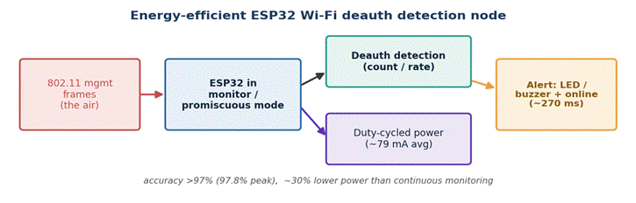
Figure 5. Energy-efficient ESP32 Wi-Fi deauthentication detection node (redrawn from Riza et al., 2025).
Hardware Components:
The core component is a low cost ESP32 microcontroller chosen for its built in Wi-Fi and its ability to run in monitor mode, paired with local indicators for on-device warnings and a network path for online notifications. The design deliberately avoids expensive capture hardware, relying on the ESP32 itself to sniff and analyse traffic. This concrete, low-power ESP32 build, including its monitor-mode capture and alerting, maps very directly onto an ESP32-S3 honeypot node.
Data Parameters:
Detection operates on captured 802.11 management frames, with the rate and count of deauthentication frames as the primary features that separate an attack from normal traffic. The system is characterised by operational parameters that matter for a fielded device, namely detection accuracy under different attack intensities, average current draw, and notification latency. These are the quantities the authors measure to show the node is both accurate and practical to run continuously.
Methodology:
The research follows a staged engineering method. The hardware and software are selected and designed first, with the ESP32 chosen for monitor mode and low cost, then detection software is developed in C and MicroPython and tested initially in a controlled laboratory. The system is then exercised under a range of deauthentication attack scenarios of varying intensity to measure real world effectiveness, and its power behaviour is evaluated to confirm the energy efficiency claims.
Result:
Under moderate and heavy attack conditions the node kept detection accuracy above 97 percent, reaching about 97.8 percent at peak attack intensity. Its duty-cycled design held average current draw to roughly 79 milliamps, about 30 percent lower than continuous monitoring, and it delivered alerts with a latency of around 270 milliseconds, confirming real time responsiveness. By combining physical indicators with online alerts the system makes threats immediately visible to users. The work establishes the ESP32 as a low-power, real-time detection platform, and its single-purpose deauthentication focus is a natural gap for a broader ESP32-S3 honeypot to extend.
Reference:
Riza, F., Febrianto Hendrakusuma, D., & Wibowo, B. (2025). An Energy-Efficient ESP32 IoT System for Real-Time Detection of WiFi Deauthentication Attacks. International Journal of Engineering Continuity, 4(3). https://ejournal.sultanpublisher.com/index.php/ijec/article/view/433

MD Eleas Biswas-2210099

1.

